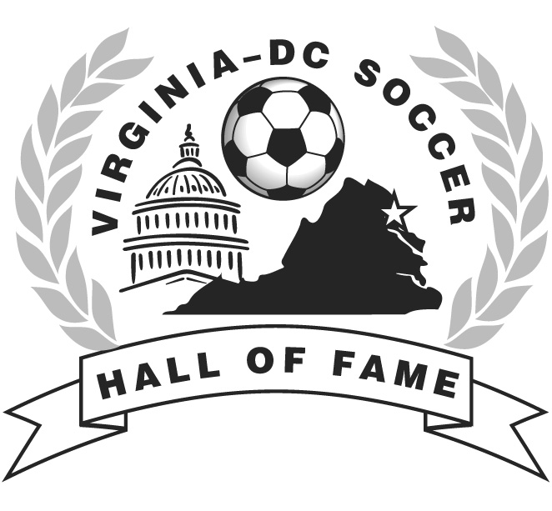
VIRGINIA-DC SOCCER HALL OF FAME

Nomination for Election to the Virginia-DC Soccer Hall of Fame

- Meritorious Service Nomination-

The person named below on this form is being nominated for election to the VA-DC Soccer Hall of Fame in the Meritorious Service category. Nominations for the class of 2021 must be received on or before 5:00pm on Tuesday, October 13, 2020. Nominations may be submitted by any recognized affiliate of USSF, VYSA, MDCVSA, or individual associated with an affiliated body.

To be eligible for election, candidates must meet the criteria within one of the following areas:

1. Coaches: Must have coached a Virginia-DC high school or college team, State Cup team, ODP team, regional team, professional team, or a successful division, club or league team for at least five seasons, or made other outstanding contributions to Virginia-DC coaching.

2. Game Officials: Must have at least 10 years as a Virginia-DC official and officiated in the center in at least one major game in Virginia-DC, or must have 10 years as a professional league referee.

3. Builder: Must have made a major, sustained positive impact on Virginia-DC soccer at the college, league, club, state, or regional level. This category includes owners, administrators, managers, or media representatives.

Name of person being nominated:

_______________________________________________________________________

Summary of nominee’s accomplishments: Why should this person be in the Virginia-DC Soccer Hall of Fame? Continue on separate sheet, if necessary.

Contact Information for person being nominated for Meritorious Service:

Address _________________________________________________________________

City, State, Zip ___________________________________________________________

Home Phone_____________________________________________________________

Office Phone_____________________________________________________________

E-mail __________________________________________________________________

This nomination is being submitted by:

Name: _____________________________________________________________

Affiliation: _______________________________________________________________

Address: ________________________________________________________________

City, State, Zip _______________________________________________________

Home Phone: ____________________________________________________________

Office Phone: ____________________________________________________________

E-Mail: __________________________________________________________________

Submit a brief biography of the person with this cover sheet along with clippings, two photographs, one recent head-shot and one action photo (if available). No other documentation is necessary at this time; no letters of recommendation or telephone calls.

Submit to:

Selection Committee
Virginia-DC Soccer Hall of Fame

c/o Julie Caramanica
Administrator
15968 Kensington Place
Dumfries, VA 22025

E-Mail: JulieC@comcast.net

Virginia Youth Soccer Association (VYSA)
Metro DC Virginia Soccer Association (MDCVASA)

(Meritorious Nomination Form Updated 5/21/2020)

